Aniebiet Daniel Akpan

Phase 4B

Evaluation of Solution
Program aims:
This program allows the user which is a manager or admin for a singular band to perform specific functions. These functions are adding, updating, deleting and viewing members, events and applicants from a database. In addition it provides help functions such as a popup display and a chatbot that aid the user in understanding the program by answering any questions they may have in regards to how to operate the program

Short falls:
The chatbot has very limited responses and is unable to learn currently. Management is very limited as certain things such as sorting display from tables according to certain requirements is unavailable. There is also no indication of which band members are playing at which event which makes admin more difficult. Lastly, users are unable to update details without filling in every block making it more time consuming and possible errors

Future Developments:
- Make chat bot more advanced
- Include more sorting functions
- Connect members to events so admin can see which members are performing
- Improve the functionality of updates to allow users to update without filling every field first.

Overall:
I am happy with the program despite the flaws. If fixed it would allow more functionality for users however it is user friendly and able to carry out the basic functions the user requires as well as provide an adequate level of help to the users.

Tester 1:
Yandisa Dambuza
Date: 12 September 2025

Screen Name | Function | Working(Y/N)
Main Screen | Navigate to Manage Members screen | Yes
 | Navigate to Manage Applicants screen | Yes
 | Navigate to Manage Events screen | Yes
 | Open Help popup | Yes
 | Open ChatBot for user questions | Yes
Manage Members | Navigate to View Members screen | Yes
 | Navigate to Add Member screen | Yes
 | Navigate to Delete Member screen | Yes
 | Navigate to Update Member screen | Yes
 | Back to Main Screen | Yes
 | Open Help popup | Yes
Add Member | Add a new member to the system | Yes
 | Back to Manage Members screen | Yes
 | Open Help popup | Yes
Delete Member | Delete a member by ID | Yes
 | Check member details before deletion | Yes
 | Back to Manage Members screen | Yes
 | Open Help popup | Yes
Update Member | Update member details by ID | Yes
 | Check member details before updating | Yes
 | Back to Manage Members screen | Yes
 | Open Help popup | Yes
View Members | Display all members | Yes
 | Back to Manage Members screen | Yes
 | Open Help popup | Yes
Manage Applicants | Navigate to View Applicants screen | Yes
 | Navigate to Add Applicant screen | Yes
 | Navigate to Delete Applicant screen | Yes
 | Navigate to Update Applicant screen | Yes
 | Back to Main Screen | Yes
 | Open Help popup | Yes
Add Applicant | Add a new applicant to the system | Yes
 | Back to Manage Applicants screen | Yes
 | Open Help popup | Yes
Delete Applicant | Delete an applicant by ID | Yes
 | Check applicant details before deletion | Yes
 | Back to Manage Applicants screen | Yes
 | Open Help popup | Yes
Update Applicant | Update applicant details by ID | Yes
 | Check applicant details before updating | Yes
 | Back to Manage Applicants screen | Yes
 | Open Help popup | Yes
View Applicants | Display all applicants | Yes
 | Sort applicants by years of experience | Yes
 | Back to Manage Applicants screen | Yes
 | Open Help popup | Yes
Manage Events | Navigate to View Events screen | Yes
 | Navigate to Add Event screen | Yes
 | Navigate to Delete Event screen | Yes
 | Navigate to Update Event screen | Yes
 | Back to Main Screen | Yes
 | Open Help popup | Yes
Add Event | Add a new event to the system | Yes
 | Back to Manage Events screen | Yes
 | Open Help popup | Yes
Delete Event | Delete an event by ID | Yes
 | Check event details before deletion | Yes
 | Back to Manage Events screen | Yes
 | Open Help popup | Yes
Update Event | Update event details by ID | Yes
 | Check event details before updating | Yes
 | Back to Manage Events screen | Yes
 | Open Help popup | Yes
View Events | Display all events | Yes
 | Sort events by date | Yes
 | Back to Manage Events screen | Yes
 | Open Help popup | Yes

Tester 2:
Jokotade Onile-Ere
Date: 13 September 2025

Screen Name | Function | Working(Y/N)
Main Screen | Navigate to Manage Members screen | Yes
 | Navigate to Manage Applicants screen | Yes
 | Navigate to Manage Events screen | Yes
 | Open Help popup | Yes
 | Open ChatBot for user questions | Yes
Manage Members | Navigate to View Members screen | Yes
 | Navigate to Add Member screen | Yes
 | Navigate to Delete Member screen | Yes
 | Navigate to Update Member screen | Yes
 | Back to Main Screen | Yes
 | Open Help popup | Yes
Add Member | Add a new member to the system | Yes
 | Back to Manage Members screen | Yes
 | Open Help popup | Yes
Delete Member | Delete a member by ID | Yes
 | Check member details before deletion | Yes
 | Back to Manage Members screen | Yes
 | Open Help popup | Yes
Update Member | Update member details by ID | Yes
 | Check member details before updating | Yes
 | Back to Manage Members screen | Yes
 | Open Help popup | Yes
View Members | Display all members | Yes
 | Back to Manage Members screen | Yes
 | Open Help popup | Yes
Manage Applicants | Navigate to View Applicants screen | Yes
 | Navigate to Add Applicant screen | Yes
 | Navigate to Delete Applicant screen | Yes
 | Navigate to Update Applicant screen | Yes
 | Back to Main Screen | Yes
 | Open Help popup | Yes
Add Applicant | Add a new applicant to the system | Yes
 | Back to Manage Applicants screen | Yes
 | Open Help popup | Yes
Delete Applicant | Delete an applicant by ID | Yes
 | Check applicant details before deletion | Yes
 | Back to Manage Applicants screen | Yes
 | Open Help popup | Yes
Update Applicant | Update applicant details by ID | Yes
 | Check applicant details before updating | Yes
 | Back to Manage Applicants screen | Yes
 | Open Help popup | Yes
View Applicants | Display all applicants | Yes
 | Sort applicants by years of experience | Yes
 | Back to Manage Applicants screen | Yes
 | Open Help popup | Yes
Manage Events | Navigate to View Events screen | Yes
 | Navigate to Add Event screen | Yes
 | Navigate to Delete Event screen | Yes
 | Navigate to Update Event screen | Yes
 | Back to Main Screen | Yes
 | Open Help popup | Yes
Add Event | Add a new event to the system | Yes
 | Back to Manage Events screen | Yes
 | Open Help popup | Yes
Delete Event | Delete an event by ID | Yes
 | Check event details before deletion | Yes
 | Back to Manage Events screen | Yes
 | Open Help popup | Yes
Update Event | Update event details by ID | Yes
 | Check event details before updating | Yes
 | Back to Manage Events screen | Yes
 | Open Help popup | Yes
View Events | Display all events | Yes
 | Sort events by date | Yes
 | Back to Manage Events screen | Yes
 | Open Help popup | Yes

Tester 3:
Kayaking Govender
Date: 15 September 2025

Screen Name | Function | Working(Y/N)
Main Screen | Navigate to Manage Members screen | Yes
 | Navigate to Manage Applicants screen | Yes
 | Navigate to Manage Events screen | Yes
 | Open Help popup | Yes
 | Open ChatBot for user questions | Yes
Manage Members | Navigate to View Members screen | Yes
 | Navigate to Add Member screen | Yes
 | Navigate to Delete Member screen | Yes
 | Navigate to Update Member screen | Yes
 | Back to Main Screen | Yes
 | Open Help popup | Yes
Add Member | Add a new member to the system | Yes
 | Back to Manage Members screen | Yes
 | Open Help popup | Yes
Delete Member | Delete a member by ID | Yes
 | Check member details before deletion | Yes
 | Back to Manage Members screen | Yes
 | Open Help popup | Yes
Update Member | Update member details by ID | Yes
 | Check member details before updating | Yes
 | Back to Manage Members screen | Yes
 | Open Help popup | Yes
View Members | Display all members | Yes
 | Back to Manage Members screen | Yes
 | Open Help popup | Yes
Manage Applicants | Navigate to View Applicants screen | Yes
 | Navigate to Add Applicant screen | Yes
 | Navigate to Delete Applicant screen | Yes
 | Navigate to Update Applicant screen | Yes
 | Back to Main Screen | Yes
 | Open Help popup | Yes
Add Applicant | Add a new applicant to the system | Yes
 | Back to Manage Applicants screen | Yes
 | Open Help popup | Yes
Delete Applicant | Delete an applicant by ID | Yes
 | Check applicant details before deletion | Yes
 | Back to Manage Applicants screen | Yes
 | Open Help popup | Yes
Update Applicant | Update applicant details by ID | Yes
 | Check applicant details before updating | Yes
 | Back to Manage Applicants screen | Yes
 | Open Help popup | Yes
View Applicants | Display all applicants | Yes
 | Sort applicants by years of experience | Yes
 | Back to Manage Applicants screen | Yes
 | Open Help popup | Yes
Manage Events | Navigate to View Events screen | Yes
 | Navigate to Add Event screen | Yes
 | Navigate to Delete Event screen | Yes
 | Navigate to Update Event screen | Yes
 | Back to Main Screen | Yes
 | Open Help popup | Yes
Add Event | Add a new event to the system | Yes
 | Back to Manage Events screen | Yes
 | Open Help popup | Yes
Delete Event | Delete an event by ID | Yes
 | Check event details before deletion | Yes
 | Back to Manage Events screen | Yes
 | Open Help popup | Yes
Update Event | Update event details by ID | Yes
 | Check event details before updating | Yes
 | Back to Manage Events screen | Yes
 | Open Help popup | Yes
View Events | Display all events | Yes
 | Sort events by date | Yes
 | Back to Manage Events screen | Yes
 | Open Help popup | Yes

Functional testing:

 | Event Name | Location | Event Date | Description
Standard | Summer Party | US, Arizona | 2025-09-30 | Solo
Extreme | Big day OUTTTTTTTT | Banddddddd | 2100-12-31 | Full Bandddddd
Abnormal | (blank) | @@@ | (Blank) | 07087

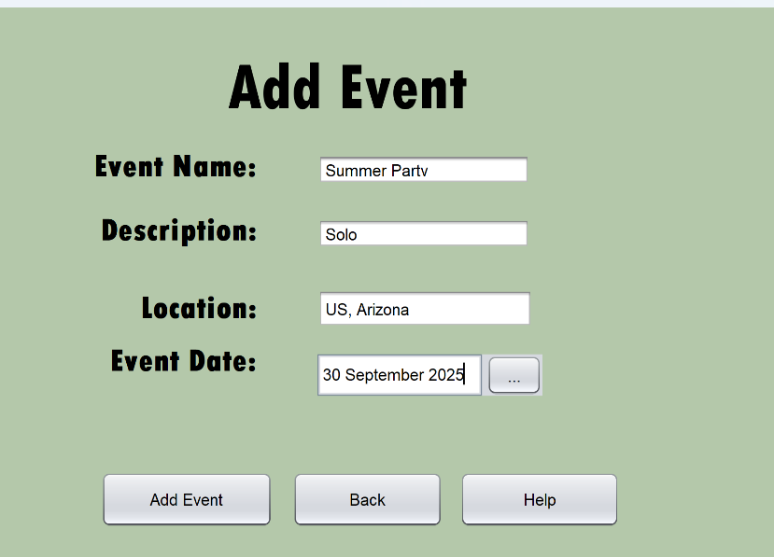
Standard Data

Expected output : Confirmation of addition to table “added”

Output:
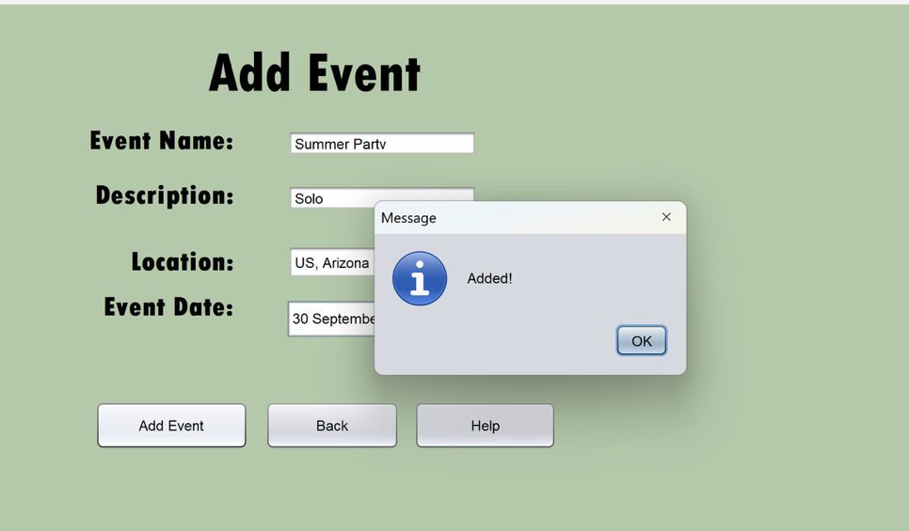

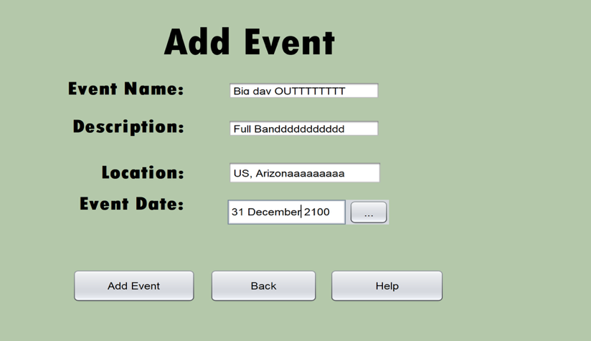
Extreme Data

Expected output : Confirmation of addition to table “added”

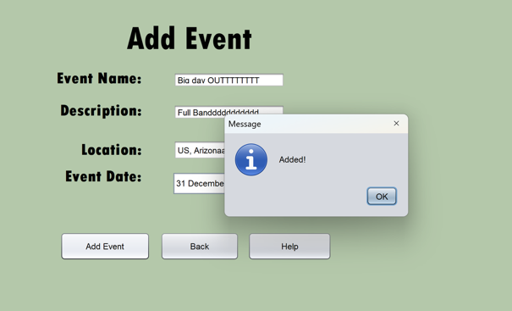
Output:
Abnormal Data
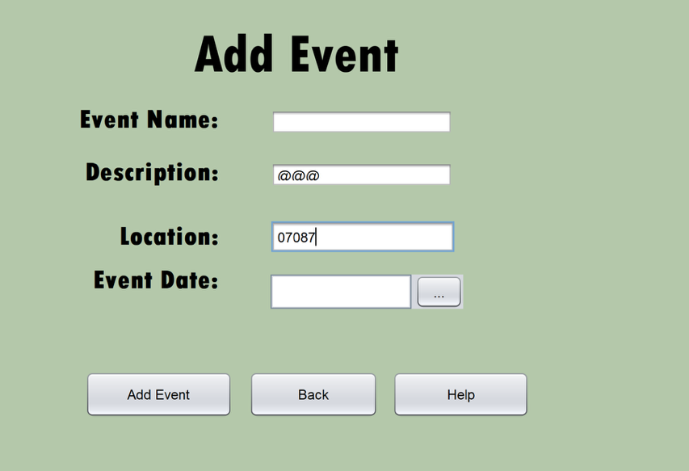
Expected output : Error message “errors detected”
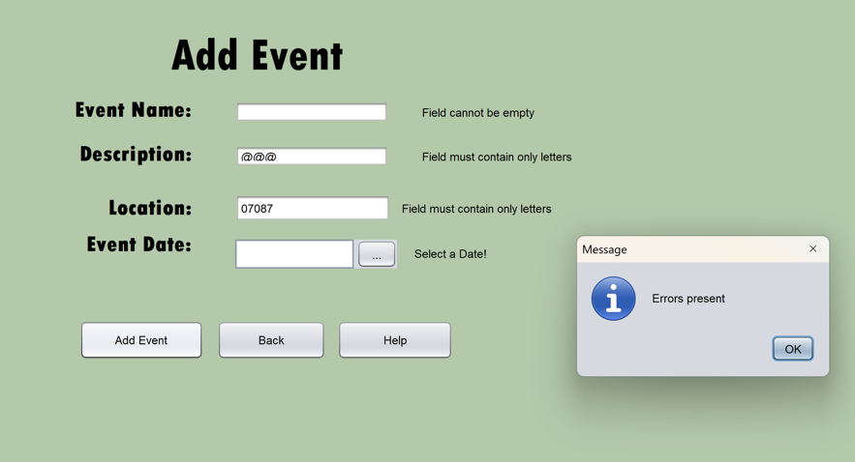
Actual Output:

 | Member ID | First Name | Surname | Phone Number | Age | Instrument | Join Date
Standard | 1 | John | Smith | 0812345678 | 25 | N/a | 2025-09-01
Extreme | 2 | Rasputinnnnnnnnn | LongSurnamee | 0999999999 | 40(max) | N/a | 1900-01-01
Abnormal | ABC123 | 1234 | @@@ | 12345 | N/a | N/a | (Blank)

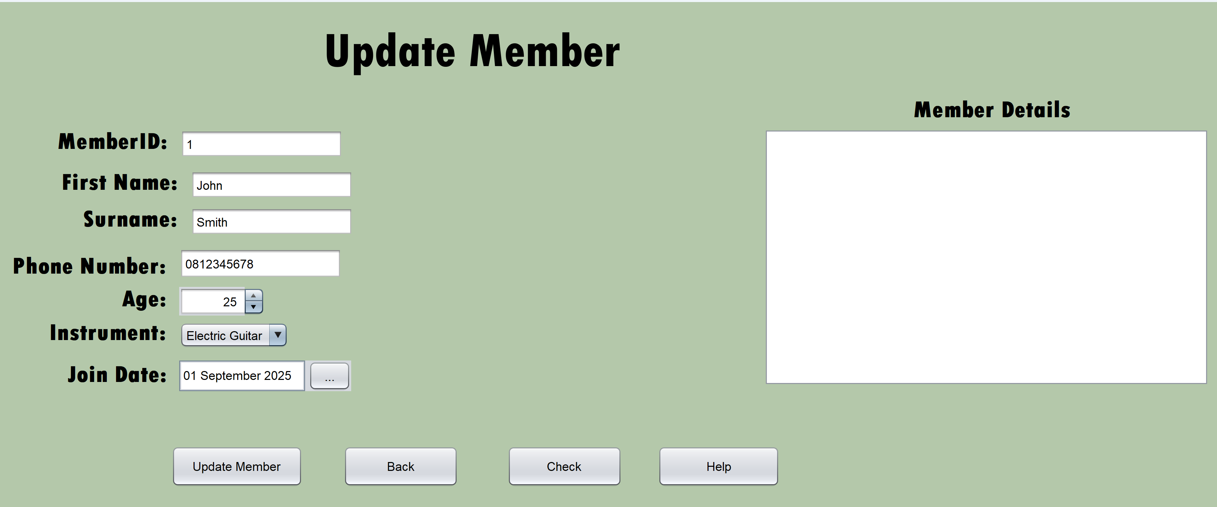
Standard Data

Expected output : Confirmation of addition to table “added”

Output:

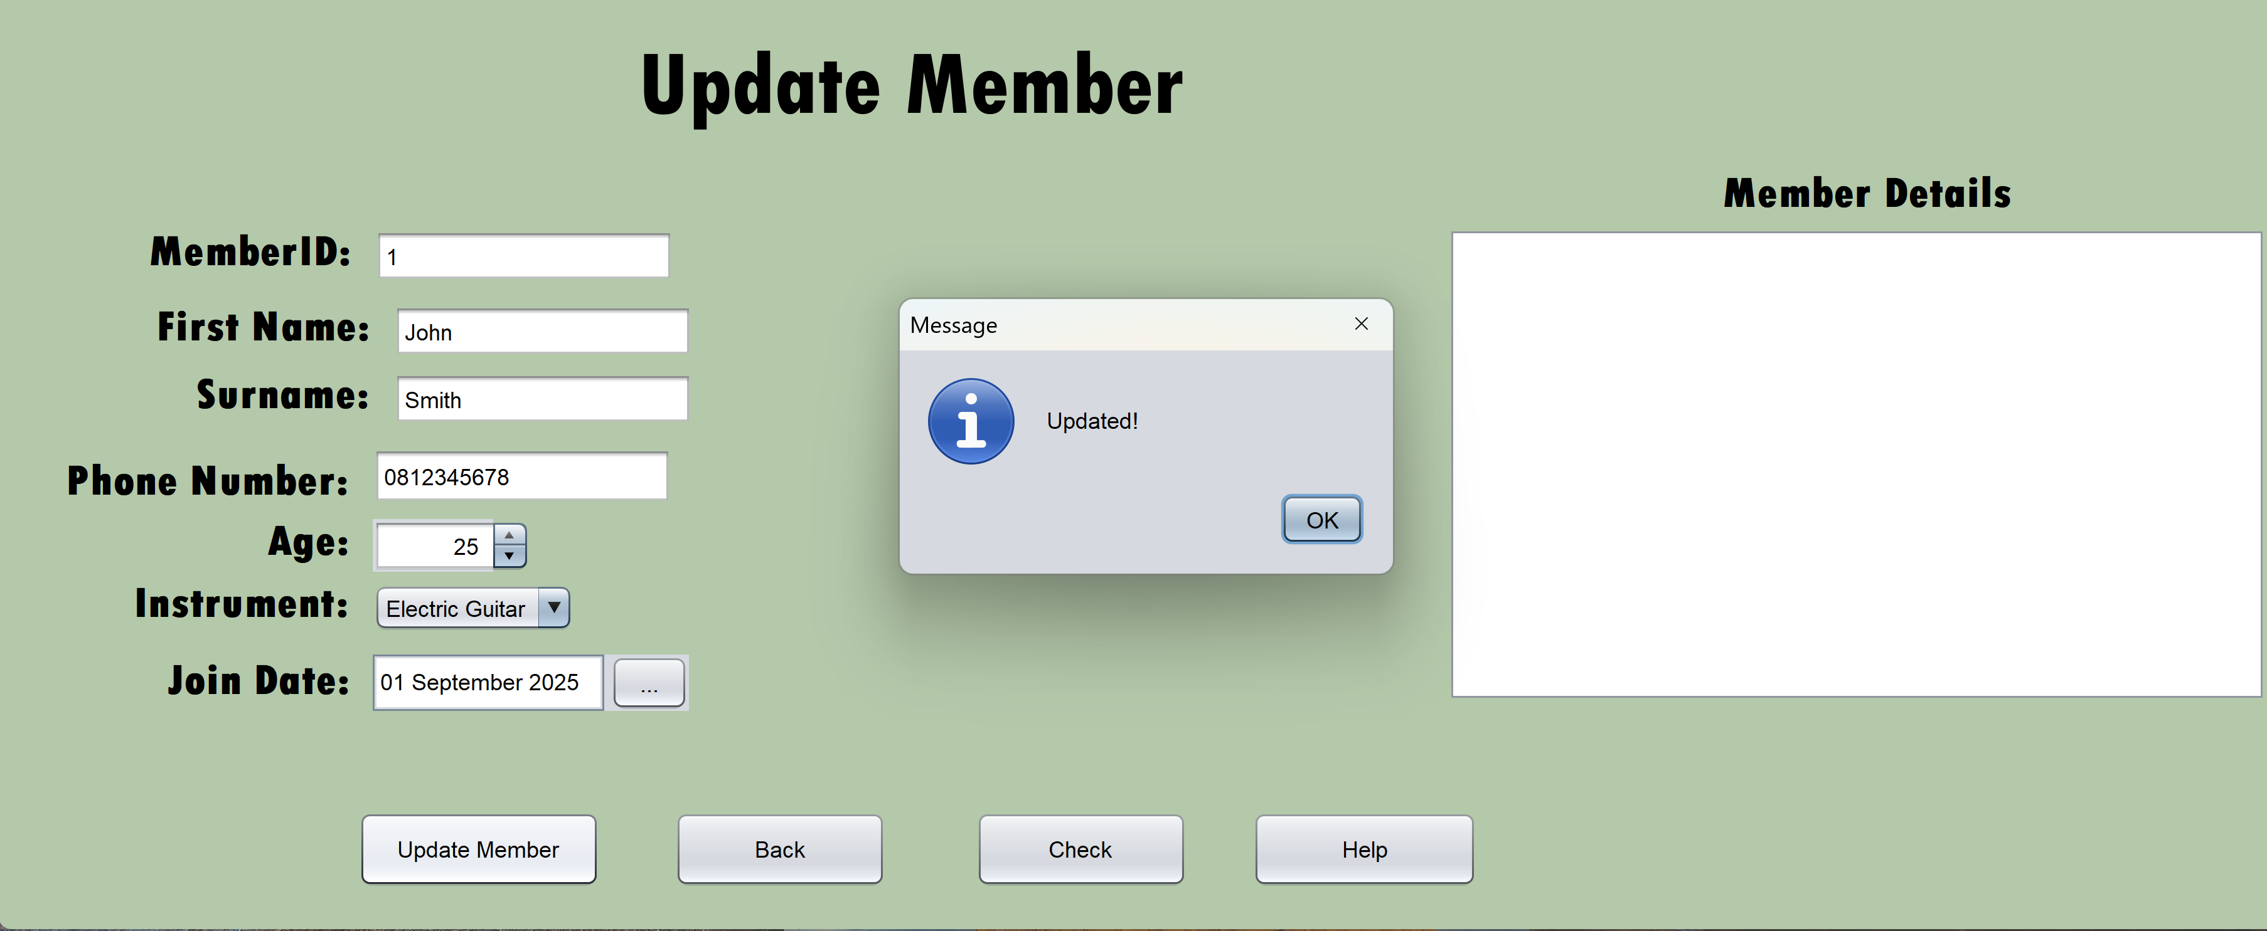

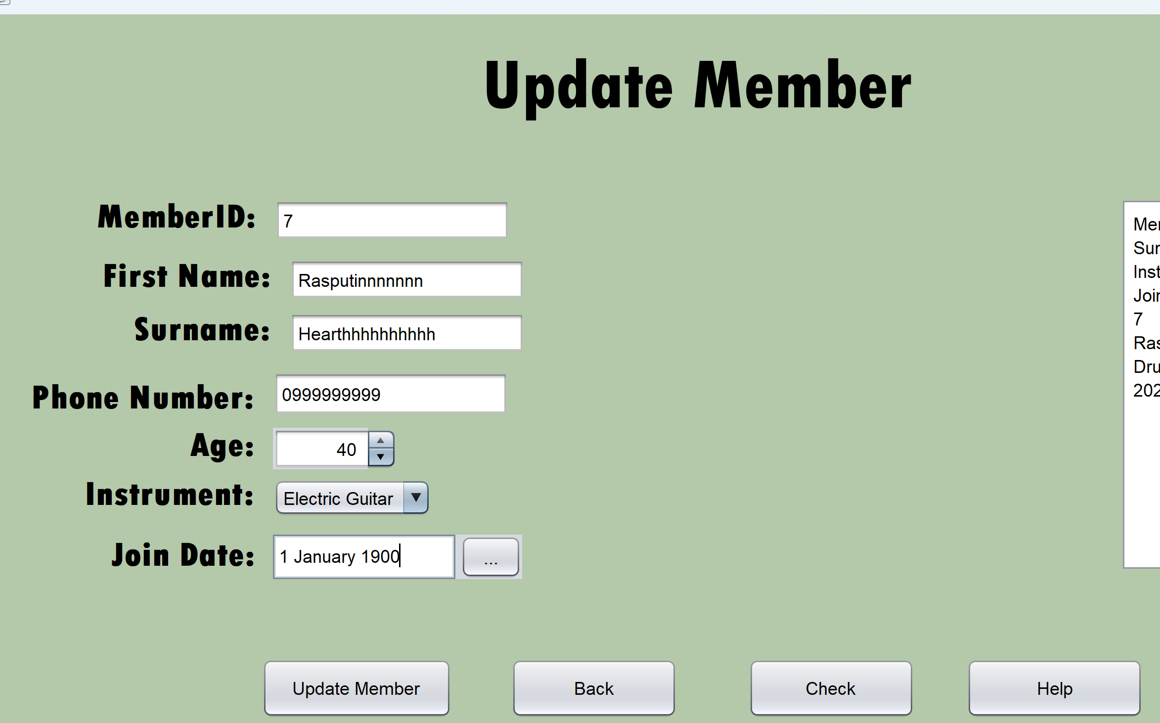
Extreme Data

Expected output : Confirmation of addition to table “added”

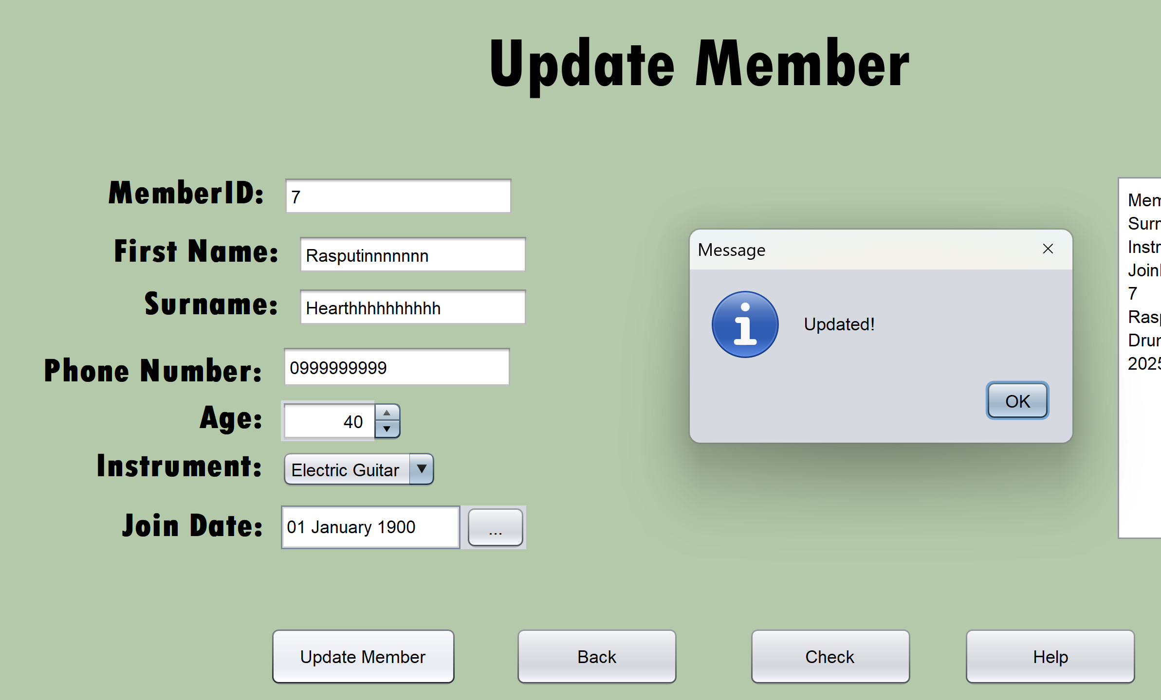
Output:
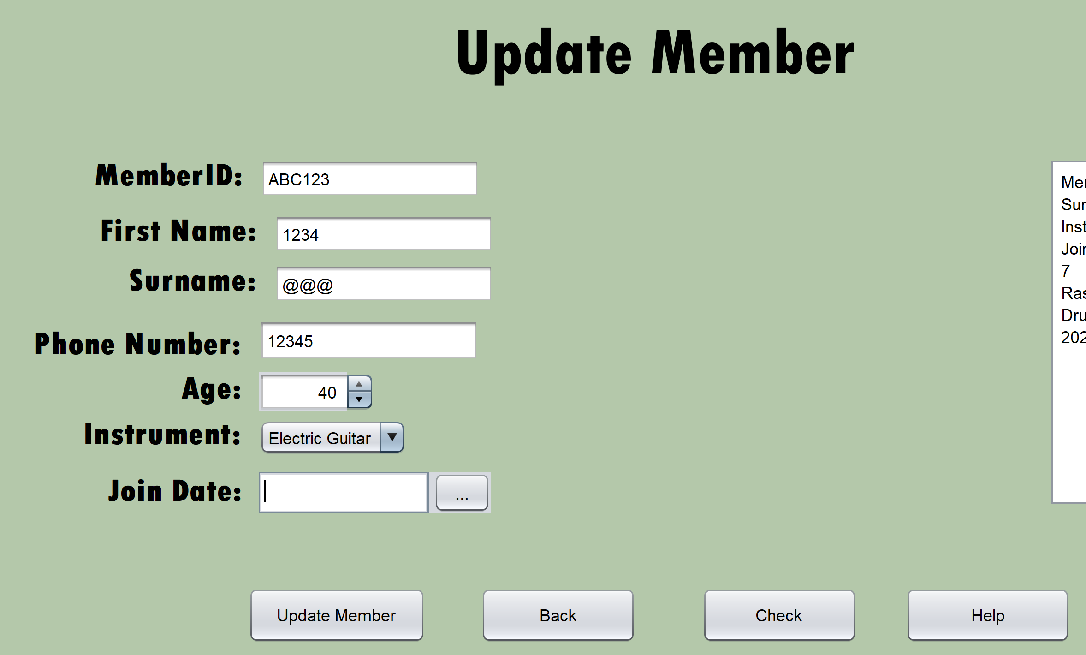
Abnormal Data

Expected output : Error message “errors detected”
Actual Output:
